

Name: **Marthumallar Verajarum**

Login ID: **marthumallar@oasis-portal.com**

Course title: **Accounting Fundamental**

Subject Code: **BHM 03**

Submission date : **14/8/2017**

**Table of Contents**

|  |  |  |
| --- | --- | --- |
| No | Details | Page |
| 1 | Executive Summary | 3 |
| 2 | Introduction | 4 |
| 3 | Assignment Question |  |
|  | Question 1 | 5-11 |
|  | Question 2 | 12-14 |
|  | Question 3 | 15-17 |
|  | Question 4 | 18-21 |
| 4 | Conclusion | 22 |
| 5 | References | 23 |
| 6 | Appendix | 24-25 |

**EXECUTIVE SUMMARY**

In this module, I had gather alots of information and I learned various ways to explain about the accounting fundamental. Accounting fundamental it’s a interesting topic to learn. Accounting fundamental is very important to every type of business. I learned how every business apply some theories about accounting fundamental to their business. I’m going to point out more details and informations about accounting fundamental and I will also explain the aspects of the question in this part. Firstly, I’m going to start the module by briefly define the role of accounting. After that, I will elaborate about a company’s profit appear as a credit on its balance sheets at the same time I also will explain the difference between accounts payable and accounts receivable. Finally, I will explain the details in reconciling an account.

**INTRODUCTION**

Accounting is the recording of financial transactions of a business or organization. It also includes the process of of summarizing , analyzing and reporting these transactions in financial statement.

Accounting is the process of communicating financial information about every business entity to users such as stakeholders and managers. The communication is generally in the form of financial statements that show in money terms the economic resources under the control of management.

The art lies in selecting the information that is relevant to the user. The principles of accountancy are applied to business entities in three divisions of practical art accounting, bookkeeping and auditing.

**Assignment Questions**

**Examples :-**

Assignment question in this part contain 4 questions

**Question 1**

In a brief but comprehensive response, define the role of accounting.

History of accounting is following below:

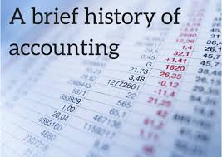

The earliest accounting records were found amongst the ruins of ancient Babylon, Assyria and Sumeria, which date back more than 7000 years. The people of that time relied on primitive accounting methods to record the growth of crops and herds. Because there is a natural season to farming and herding, it is easy to count and determine if a surplus had been gained after the crops had been harvested or the young animals weaned.

When medieval Europe moved to a monetary economy in the 13th century, sedentary merchants depended on bookkeeping to oversee multiple simultaneous transactions financed by bank loans. One important breakthrough took place around that time. The introduction of double-entry bookkeeping, which is defined as any bookkeeping system in which there was a debit and credit entry for each transaction, or for which the majority of transactions were intended to be of this form. The historical origin of the use of the words ‘debit’ and ‘credit’ in accounting goes back to the days of single entry bookkeeping in which the chief objective was to keep track of amounts owed by customers (debtors) and amounts owed to creditors. Thus, ‘Debit’, from the Latin word debere means ‘he owes’ and ‘Credit’, from the Latin word credere, means, ‘He trusts’.

The earliest evidence extant evidence of full double-entry bookkeeping is the Farolfi & Company were a firm of Florentine merchants whose head office was in Nimes and who also acted in moneylenders to the Archbishop of Arles, their most important customer. The oldest discovered record of a complete double-entry system is the Messari (Italian : Treasure’s) accounts of the city of Genoa in 1340. The messari accounts contain debits and credits journalized in a bilateral form and contain balances carried forward from the preceding year. Therefore, they enjoy general recognition as a double-entry system.

Luca Pacioli’s “Summa de Arthmetica, Geometria, Proportioni et Proportionalita” (early Italian, “Review of Arithmetic, Geometry, Ratio and Proportion) was first printed and published in Venice in 1494. It included a 27 page treatise in bookkeeping, “Particulars de Computis et Scripturis” (Latin, “Details of calculation and Recording). It was written primarily for and sold mainly to merchants who used the book as a reference text as a source of pleasure from the mathematical puzzles it contained and to aid the education of their sons. It represents the first known printed treatise on bookkeeping and it is widely believed to be the forerunner of modern bookkeeping practice.

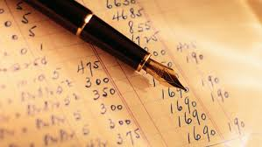

**Double entry system**

Double entry accounting, also called double entry bookkeeping, is the accounting system that requires every [business transaction](http://www.myaccountingcourse.com/accounting-basics/business-events) or event to be recorded in at least two [accounts](http://www.myaccountingcourse.com/accounting-basics/accounts). This is the same concept behind the [accounting equation](http://www.myaccountingcourse.com/accounting-basics/accounting-equation). Every [debit](http://www.myaccountingcourse.com/accounting-dictionary/debit) that is recorded must be matched with a credit. In other words, [debits and credits](http://www.myaccountingcourse.com/accounting-basics/debit-vs-credit) must also be equal in every accounting transaction and in their total.

Every modern accounting system is built on the double entry bookkeeping concept because every business transaction affects at least two different accounts. For example, when a company takes out a loan from a bank, it receives cash from the loan and also creates a liability that it must repay in the future. This single transaction affects both the [asset accounts](http://www.myaccountingcourse.com/accounting-basics/asset-accounts) and the [liabilities accounts](http://www.myaccountingcourse.com/accounting-basics/liability-accounts).

Examples of how debits and credit affect all of the accounts.

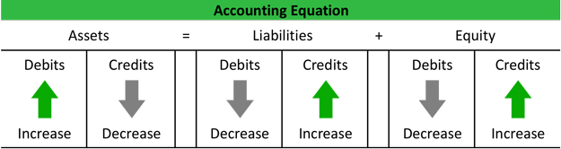

As we can see from the equation, assets always have to equal liabilities plus equity. In other words, overall debits must always equal overall credits. For example, if an asset account is increased or debited, either a liability or equity account must be increased or credited for the same amount.

This is always the case except for when a business transaction only affects one side of the accounting equation. For example, if a restaurant purchases a new delivery vehicle for cash, the cash account is decreased by the cash disbursement and increased by the receipt of the new vehicle. This transaction does not affect the liability or [equity accounts](http://www.myaccountingcourse.com/accounting-basics/equity-accounts), but it does affect two different assets accounts. Thus, assets are decreased and immediately increased resulting in a net effect of zero.

**The Role Of Accounting**

Accounting often called “the language of business”. It communicates so much of the information that owners, managers and investors need to evaluate a company’s financial performance. These people are all stakeholders in the business. Purpose of accounting is to help stakeholders make better business decisions by providing them with financial information. Accounting can be divided into two major fields :-

**Management accounting**

Management accounting plays a key role in helping managers carry out their responsibilities. In preparing analyzing and communicating such information accountants work with individuals from all functional area of the organization such as human resources, operations, marketing and finance.

**Financial accounting**

Financial accounting provides information not only to internal managers but also to people outside the organization such as investors, creditors, government agencies, suppliers, employees and labor unions to assist them in assessing a firm’s financial performance.

**Users of accounting**

Users of accounting informations can be divided into internal and also external users and they also got various reasons for using the accounting informations and knowledge.

|  |  |  |
| --- | --- | --- |
| **Internal users** | **Users** | **External users** |
| -managers  -owners  -employees |  | -creditors or banker  -governments  -customers |

1. **Internal users**

**- The managements**

- They need the accounting information and knowledge to assist them in planning, controlling and making decisions as well as in the formulation and implementation of policies in an organization.

**- Employees**

- They are interested in information about the stability and profitability of their employers. They need the information to assist them in assessing the ability of the enterprise to provide remuneration, retirement benefits and employments opportunities.

**- Owners**

- The owners will be interested in the profits earned from their investment in the business and the financial stability of the business.

1. **External users**

**- Creditor or bankers**

- They are interested to know the ability of the business in repaying the amount owing to them

**- Governments**

- The government is interested in the financial statements and reports of a business for tax purposes.

**-Customers**

- Goods accounting controls reduction of cost of production.

- Reduction of prices of the goods they purchase.

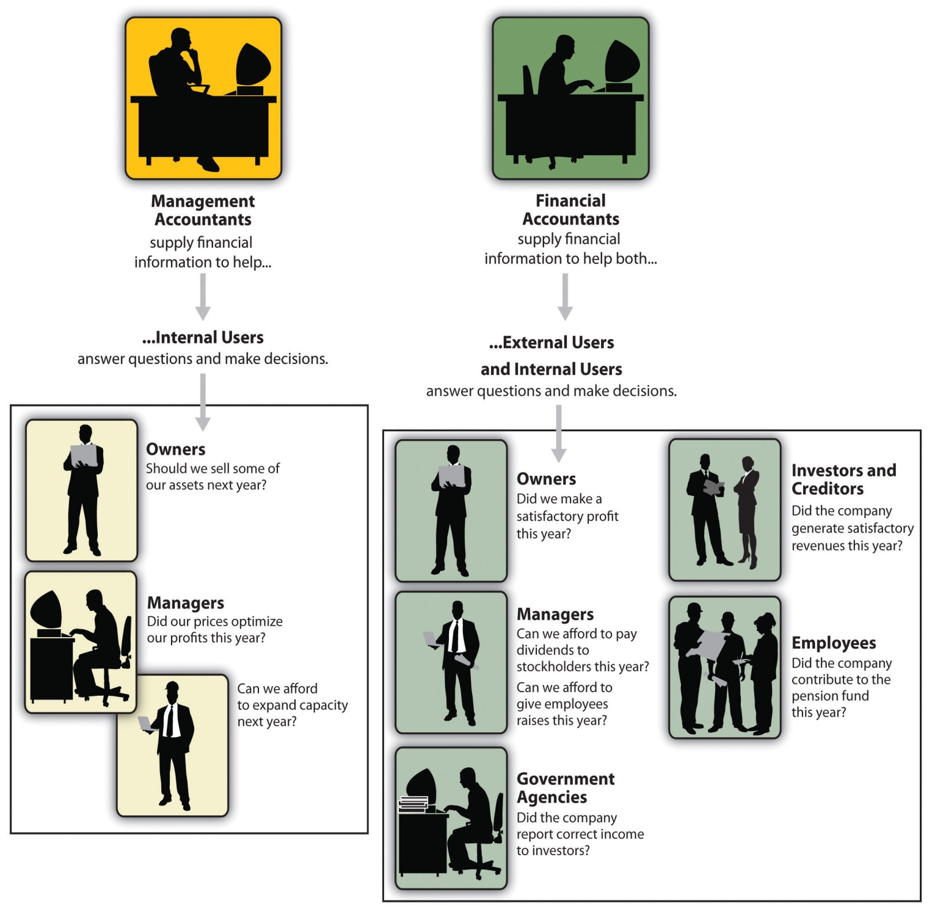

**Process of Accounting**

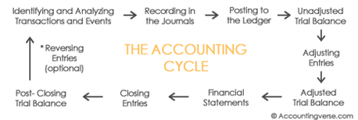

**Transaction  
-**an instant of buying or selling something

**Sources of documents  
-**the original records containing the information and details to substantiate a transaction entered in an accounting system

**Journals   
-**transaction are recorded in a book known as journal

**Ledger   
-**transactions classified in a suitable manner and recorded in another book

**Adjustments   
-**a small alteration or the process of adapting or becoming used to a new situations.

**Financial of statements  
-**the process the result of the full years working is determined through final decision.

**Trial balance   
-** the arithmetical of the books of account tested

**Question 2**

What is the difference between accounts payable and accounts receivable?

When a company orders and receives goods in advance of paying for them, we say that the company is purchasing the goods on accountor on credit*.* The supplier of the goods on credit is also referred to as a creditor. If the company receiving the goods does not sign a promissory note, the vendor's bill or invoice will be recorded by the company in its liability account Accounts Payable.

Accounts receivableis the money that a company has a right to receive because it had provided customers with goods and services. For an example, a manufacturer will have an account receivable when it delivers a truckload of goods to a customer on June 1 and the customer is allowed to pay in 30 days. From June 1 until the company receives the money, the company will have an account receivable and the customer will have an account payable.

Our example reminds me of an old saying, "There are two sides to every transaction." In accounting we also expect symmetry: Company A has a sale and a receivable, Company B has a purchase and a payable.

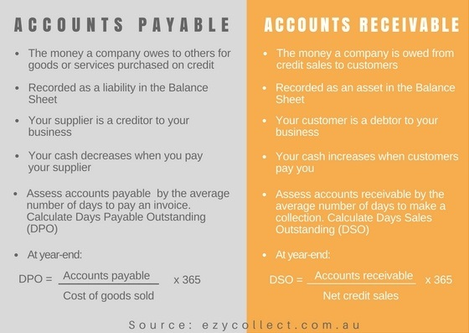

**Debtor**

Debtor is the person who has taken the goods on credit or money on debt. He has to pay his debt. To whom, he has to pay, will show him as debtor in his debtors' list. When a person take loan or goods on credit from many parties. He will be debtor of all these parties. If he will not pay his debt or money, his properties can be used for paying his debt as per court's order. For an example, Mr. A has bought goods from Mr. B of Rs. 1,00,000 on credit. Mr. A is the debtor of Mr. B. Mr. B has taken debt from Mr. A of Rs. 1,00,000 at the rate of interest 1% per month. Here, Mr. B is the debtor of Mr. A.  
  
  
  
**Creditor**  
 Creditor is the person who has given the goods on credit or money to other party in the form of debt. He has to take his money or debt with [interest](http://www.svtuition.org/2010/02/interest.html). In business, mostly, he will be supplier or vendor. If he sells goods on credit to many parties. All these parties will say him creditor. He has right to demand the money from debtors. For an example, Mr. A has bought goods from Mr. B of Rs. 1,00,000 on credit. Mr. B is the creditor of Mr. A.  
Mr. B has taken debt from Mr. A of Rs. 1,00,000 at the rate of interest 1% per month. Here, Mr. A is the creditor of Mr. B.  
  
  
 

**Balance sheet**

The accounting balance sheet is one of the major financial statements used by accountants and business owners. The other major financial statements are the [income statement](https://www.accountingcoach.com/terms/I/income-statement), [statement of cash flows](https://www.accountingcoach.com/terms/S/statement-of-cash-flows), and [statement of stockholders' equity](https://www.accountingcoach.com/terms/S/stockholders-equity)) The balance sheet is also referred to as the statement of financial position.

**Debtor and Creditor in Balance Sheet**  
 In the balance sheet of debtor, creditor will show as current liability because debtor has to give money to his creditor. So, it is the financial responsibility of debtor to pay creditor on the time. So, every financial responsibility will be shown in the liability side. When debtor will pay whole amount to his creditor, debtor will not show it balance sheet.

In the balance sheet of creditor, debtor will show as current asset because creditor has to take money from debtor. He can file the case against debtor if debtor will not pay his debt on the maturity. Creditor will have the proof about his goods sold on credit or given loan.

**Question 3**

What does a company’s profit appear as a credit on its balance sheets?

**The elements of balance sheet**

The balance sheet is one of the main financial reports prepared by company accountants. It offers one of the best overall views of your business's financial situation. The three major elements of the balance sheet are assets, liabilities and owners' equity. The statement shows assets on the left and liabilities and equity on the right and it follows the basic equation assets equal liabilities plus owners equity.

**Assets**

The assets section shows items your company owns that have tangible value. It includes current assets, along with property and equipment, investments and intangible assets. The current assets section is compared to current liabilities to figure out your basic liquidity, or ability to pay off short-term debt. Current assets include cash, securities and accounts receivable, which can all generally be converted to cash within 12 months. Property and equipment are assets with a longer-term use that would generally take longer to sell. Longer-term assets are more often used to operate your business.

Asset accounts usually have [debit balances](https://www.accountingcoach.com/blog/what-is-a-debit-balance) while liabilities and owners or [stockholders equity](https://www.accountingcoach.com/blog/what-is-stockholders-equity) usually have [credit balances](https://www.accountingcoach.com/blog/what-is-a-credit-balance). When a company provides services for cash, it’s asset cash is increased by a debit and its [owners equity](https://www.accountingcoach.com/blog/what-is-owners-equity) is increased by a credit. The credit is initially recorded in a revenue account, but revenue accounts are [temporary accounts](https://www.accountingcoach.com/blog/what-is-a-temporary-account) that cause owners equity to increase.  
  
 If the owner withdraws some cash for personal use, the asset cash will decrease through a credit and the owner's equity will decrease through the debit part of the accounting entry. The debit might initially be recorded in the sole proprietor's Drawing account but this [account](https://www.accountingcoach.com/blog/what-is-an-account) is also a temporary account that will cause the owner's equity to decrease.  
  
 Generally, the credit balance reported in the owners or stockholders equity section of the balance sheet reflects the owners' investments in the company plus the profits earned minus the amounts distributed to the owners since the time that the company began.

**Liabilities**

The liabilities section is simply divided into current and long-term liabilities. Current liabilities are debts due within the next 12 months. Notes payable and accounts payable are common short-term debt accounts. High near-term debt obligations stifle growth and may put you in a financial bind. Long-term debt includes loans for buildings and other long-term asset loans. The balance of this section provides a look at how leveraged your company is to lenders over the long haul. Ongoing debt payments reduce cash flow and limit growth.

## Owners Equity

Owners equity is mathematically determined to be the difference between your assets and liabilities. In essence, whatever you have left if you were to sell all of your assets and pay off debt is the value of the company at the present time. Equity actually includes a variety of accounts, but most commonly it refers to paid-in capital and retained earnings. Paid-in capital is the par value, or starting price of your shares if you are a public company. Retained earnings is the accumulated value of income you have collected and retained in the company over time. If you distribute dividends to owners or shareholders, this reduces the value of retained earnings.

**Examples of Balance sheet :-**

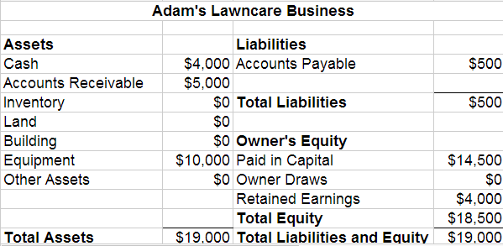

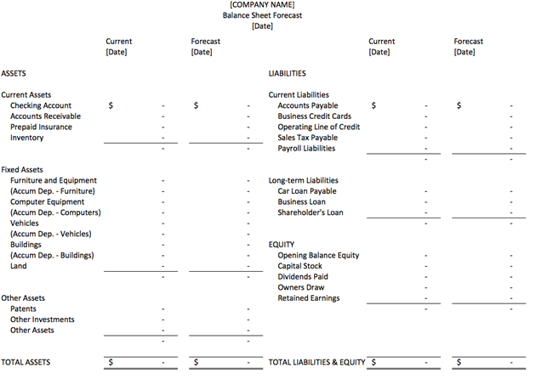

**Question 4**

What is meant by reconciling an account ?

Reconciliation

Reconciliation is an accounting process that uses two sets of records to ensure figures are accurate and in agreement. Reconciliation is the key process used to determine whether the money leaving an account matches the amount spent, ensuring the two values are balanced at the end of the recording period.

Reconciling an account often means proving or documenting that an account balance is correct. For example, we reconcile the balance in the [general ledger account](https://www.accountingcoach.com/blog/what-is-a-general-ledger-account) Cash in Checking to the balance shown on the bank statement. The objective is to report the correct amount in the general ledger account Cash in Checking. You will often need to adjust the general ledger account balance for items appearing on the bank statement that were not entered in the general ledger account.  
  
 I recall being asked to reconcile the general ledger account Freight Payable. What I needed to do was provide documentation that the balance in Freight Payable was proper. I proceeded to look at the shipments of recent [sales](https://www.accountingcoach.com/blog/what-are-sales" \o "What are sales?)and then determined how much we would be obligated to pay for the freight on those sales. We then adjusted the balance in Freight Payable to my documented amount. This reconciliation was done to have the correct account balance and to provide the outside auditors with documentation which could easily be reviewed.  
  
 I also reconciled the balance in Utilities Payable by computing the daily cost of each utility that the company used. The cost per day was then multiplied by the number of days since the last meter reading date shown on the utility bills already entered in our accounting system. We then adjusted the Utilities Payable account balance to be equal to the documented amount.

**Bank Reconciliation**

A company's [general ledger account](https://www.accountingcoach.com/terms/G/general-ledger-account) Cash contains a record of the transactions checks written, receipts from customers. that involve its checking account. The bank also creates a record of the company's checking account when it processes the company's checks, deposits, service charges, and other items. Soon after each month ends the bank usually mails a [bank statement](https://www.accountingcoach.com/terms/B/bank-statement) to the company. The bank statement lists the activity in the bank account during the recent month as well as the balance in the bank account.

When the company receives its bank statement, the company should verify that the amounts on the bank statement are consistent or compatible with the amounts in the companies cash account in its general ledger and vice versa. This process of confirming the amounts is referred to as reconciling the bank statement, bank statement reconciliation, bank reconciliation, or doing a "bank rec." The benefit of reconciling the bank statement is knowing that the amount of cash reported by the company companies books is consistent with the amount of cash shown in the bank's records.

In this case bank plays main role of financial institution that gives monetary services. We took Malaysia bank as example for here now, there are many local banks and international banks that gives services such as of the following:

**Banks in Malaysia**

**Local Banks**

1. Maybank
2. Cimb Bank
3. Public Bank
4. EON Bank
5. Bank Rakyat
6. RHB Bank
7. Bank Simpanan Nasional

**International Banks**

1. HSBC
2. Citibank
3. OCBC Bank
4. Standard Chartered
5. United Overseas Bank (UOB)

**The type of accounts in banks**

|  |
| --- |
| **Accounts** |
| 1. Saving account |
| 1. Deposit account |
| 1. Current account |

**Bank Reconciliation Process**

### Step 1. Adjusting the Balance per Bank

We will demonstrate the bank reconciliation process in several steps. The first step is to adjust the balance on the bank statement to the true, adjusted, or corrected balance.

### Step 2. Adjusting the Balance per Books

The second step of the bank reconciliation is to adjust the balance in the company's Cash account so that it is the true, adjusted, or corrected balance.

### Step 3. Comparing the Adjusted Balances

After adjusting the balance per bank (Step 1) and after adjusting the balance per books (Step 2), the two adjusted amounts should be equal. If they are not equal, you must repeat the process until the balances are identical. The balances should be the true, correct amount of cash as of the date of the bank reconciliation.

### Step 4. Preparing Journal Entries

[Journal entries](https://www.accountingcoach.com/terms/J/journal-entry) must be prepared for the adjustments to the balance per books (Step 2). Adjustments to increase the cash balance will require a journal entry that debits Cash and credits another account. Adjustments to decrease the cash balance will require a credit to Cash and a debit to another account.

**Example Bank Reconciliation Statement**

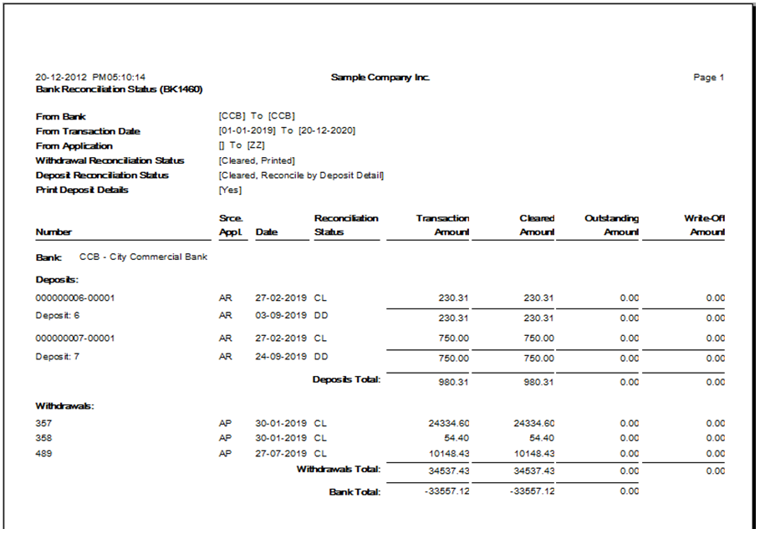

**CONCLUSION**

Finally, I studied and focused about accounting fundamental. Accounting is the systematic and comprehensive recording of financial transactions pertaining to a business, and it also refers to the process of summarizing, analyzing and reporting these transactions to oversight agencies and tax collection entities. Accounting also a process of systematically recording, measuring and communicating information about financial transactions. Accounting is tremendously important because it is the language of business.

**References**

**1.** [**http://www.accountingverse.com/accounting-basics/accounting-cycle.html**](http://www.accountingverse.com/accounting-basics/accounting-cycle.html)

**2.** [**http://www.investopedia.com/terms/r/reconciliation.asp**](http://www.investopedia.com/terms/r/reconciliation.asp)

**3.** [**https://www.accountingcoach.com/blog/accounts-payable-accounts-receivable**](https://www.accountingcoach.com/blog/accounts-payable-accounts-receivable)

**4.** [**https://www.accountingcoach.com/accounts-payable/explanation**](https://www.accountingcoach.com/accounts-payable/explanation)

**5.** [**https://www.accountingcoach.com/blog/what-is-accounts-receivable**](https://www.accountingcoach.com/blog/what-is-accounts-receivable)

**6.** [**https://www.accountingcoach.com/blog/debtor**](https://www.accountingcoach.com/blog/debtor)

**7.** [**https://www.accountingcoach.com/balance-sheet/explanation**](https://www.accountingcoach.com/balance-sheet/explanation)

**8.** [**http://smallbusiness.chron.com/elements-balance-sheet-55903.html**](http://smallbusiness.chron.com/elements-balance-sheet-55903.html)

**9.** [**http://www.myaccountingcourse.com/accounting-basics/double-entry-accounting**](http://www.myaccountingcourse.com/accounting-basics/double-entry-accounting)

**10.** [**https://www.merriam-webster.com/dictionary/accounting**](https://www.merriam-webster.com/dictionary/accounting)

**11.** [**https://www.quora.com/What-is-the-difference-between-debtors-and-creditors**](https://www.quora.com/What-is-the-difference-between-debtors-and-creditors)

**12.** [**http://financial-dictionary.thefreedictionary.com/Debtor+and+Creditor**](http://financial-dictionary.thefreedictionary.com/Debtor+and+Creditor)

**13.** [**https://courses.lumenlearning.com/finaccounting/chapter/users-of-accounting-information/**](https://courses.lumenlearning.com/finaccounting/chapter/users-of-accounting-information/)

**14.** [**https://www.accountingcapital.com/basic-accounting/who-are-the-users-of-accounting-information/**](https://www.accountingcapital.com/basic-accounting/who-are-the-users-of-accounting-information/)

**15.** [**http://www.accountingnotes.net/accounting/users-of-accounting-information-internal-and-external-users/3663**](http://www.accountingnotes.net/accounting/users-of-accounting-information-internal-and-external-users/3663)

**APPENDIX**





